HA=HA
HAPPY ANIMALS=HARMONIOUS AGILITY
Spring Agility Trials  April 18 and 19, 2020  Ironwood Event Center  Reno, Nevada  Judge:  Kari Hammargren  Double run format  Building and Ring Surface info:  Indoor arena on packed dirt  Contact Surface:  Textured rubber  Crating Set up times:  Crating set up is after the ring has been set up  Ring set up to begin at 3 pm on Friday the 17th.  All help is appreciated!!  Briefing at:  Saturday and Sunday: 7:30 a.m.  First dog on the line at:  Saturday and Sunday: 8 a.m. | Preliminary Class Order:  May change depending on weather, judges preference, time or number of entries  Saturday  Class: Double Run Single Run  Regular 2  Chances 2  Tunnelers 2  Touch n Go 2  Sunday  Class: Double Run Single Run  Regular 2  Barrelers 2  Weavers 2  Jumpers 2

Entries Open on:  February 2, 2020  Entries Close on:  April 15,2020  Or as trial limits are met  Day of entries will be accepted until trial limits are met.  Crating available:  Crating space is available within the building  Entry Limits:  Limited to maximum of 500 runs per day  Move ups:  Move ups will be accepted in writing only (email) by April 17, 2020  Move ups at the trial may be made using the form available at the Secretary’s area. These forms must be in the Secretary’s hands by 15 minutes after the last dog has run.  Day of show Entries:  Day of entries will be accepted until trial limits are met  Refunds:  There will be no refunds for entries withdrawn after the closing date, or in the event a dog and/or handler are dismissed from competition regardless of the reason for such dismissal.  Refunds will be issued for bitches in season if submitted in writing BEFORE the trial date, with a statement from your veterinarian | Show Committee  Chief Course Builder……Cherie Singer  Equipment………………….Bob Conatser  Awards………………….…….Pat Conatser  Chief Ring Steward….Barbara Harkey  Chief Scorekeeper…….Melissa Hardy  Hospitality……………….…Pat Conatser  Worker’s Raffle……....Stephanie Bohl  Agility Trial Secretary  Melissa Hardy  475 Sunset Springs Lane, Sparks, NV 89441  775 772-2172  herdnlab@wyoming.com  Agility Trial Chair  Pat Conatser  15 Moonbeam Ct, Sparks, NV 89441  775 425-5560  Confirmations:  Confirmations will be sent as received. Additional trial information will be sent to entrants during the week before the trial.  Food info:  HA=HA provides morning coffee and tea with continental breakfast foods.  Ironwood Event Center will serve PRE ordered sandwiches for lunch. Please fill out and return the order form by April 15th.  Volunteer info:  We will have a sign up board at ringside for volunteer/workers.  HA=HA will “pay” workers in raffle tickets for the Workers Only Raffle.  Awards and Ribbons:  Placement ribbons will be awarded for First through Fourth places for each class and height division. Chances is a pass/fail class with no placement ribbons awarded.  First place is Blue  Second place is Red  Third place is Yellow  Fourth place is White  Qualifying Rosettes will be awarded to each class and height division.  New title ribbons will be available  All ribbons will be self-serve and available at the awards table.
Jump Height Info:
MEASURING
Measurement forms may be obtained at:
https://www.nadac.com/WPsite/wp-content/uploads/2019/06/HeightCardForm.pdf
Dogs which require measuring:
Dogs in the Proficient Category, Novice, Open or Elite jumping 4”, 8”, 12” or 16”

Dogs which do not need to be measured:
Dogs jumping 16” in the Veteran or Junior Handler Division
Dogs jumping 20”
Dogs in the Skilled Category
Dogs with a permanent height card
Dogs listed on the Height Exemption List
JUMP HEIGHTS
There are four Standard Division-Proficient jump heights: 8”, 12”, 16”, and 20”.
There are four Standard Division-Skilled jump heights: 4”, 8”, 12”, and 16”.
There are four jump heights for the Veterans and Junior Handler divisions: 4”, 8”, 12”, and 16”.
Please see the NADAC Rulebook for the full jump height table

Brief Summary of Rules:
Please refer to www.nadac.com for a full explanation of all NADAC rules and up to date information.

- Please note that NADAC trials should provide a safe and fun environment for both exhibitors and their dogs.
- Aggressive dogs will not be tolerated and will be excused from the trial.
- The show committee has the right to refuse any entry. Anyone not currently in good standing with NADAC will not be allowed to enter this trial.
- Exhibitors, through submission of entry, acknowledge that they are knowledgeable of NADAC rules and regulations, and agree to abide by all rules in effect at the time of this trial.
- No entry fee will be refunded if the trial cannot open or be completed by reasons of riots, civil disturbances, fire, acts of God, public emergency, an act of a public enemy, or any other cause beyond the control of the organizing committee.
- Checks not honored by the bank do not constitute a valid entry fee. There will be a $25.00 service charge for bank returned checks.
- Dog must be registered and have a valid registration number before entries will be accepted. http://nadac.com/afrm/dogregfrm.asp A copy of the current Exhibitors Handbook may be downloaded free from the NADAC web site: www.nadac.com
- Bitches in heat, lame, or blind dogs are ineligible for entry, as is any dog with a deformity which may cause a judge to not be able to reasonably assess the dog’s ability to function and perform agility obstacles safely, and in a manner that is in the best interest, health and welfare of the dog.
- No food, clickers, or other aids or devices shall be permitted on the course or within 10 feet of the ring. Food or a small non-audible toy can be in a secure container (ziplock bag is acceptable) in your pocket during your run but it cannot be used during your run, nor can you indicate to the dog it is there. Only Intro and Novice handlers my bring a non-audible toy into the ring for training purposes. They cannot earn a Qualifying score and must declare to the judge they are training before they commence their run. Please read the Exhibitor’s Handbook for more information about toys and training in the ring.
- The sponsoring clubs will not be responsible for the loss or damage to any dog exhibited, or for the possessions of any exhibitor whether the result be accident or other cause. It is distinctly understood that every dog at this event is in the care and control of his owner or handler during the entire time the dog is on the show premises.

IRONWOOD RULES

PLEASE REVIEW CAREFULLY

We are very fortunate to use this wonderful facility for our agility trials. In order to be able to keep on using it, we have agreed that our exhibitors will cooperate with the following rules:

Dogs are to be leashed at all times unless in the ring or in a designated off-leash area.

Exhibitors are NOT to use the dirt planters to potty their dogs. (Please stay out of the dirt planters altogether.) Dogs are to be walked on-leash to the bare dirt, sagebrush areas to potty. If at all possible, do not allow your dogs to potty on any grass.

All exhibitors must leave the facility Sunday after the trial. No overnight camping Sunday evening.

If BBQ’s are used, they must be gas BBQ’s – no charcoal please.

Thanks for your cooperation. We really need your help to maintain our use of this facility.

No one is to be in any of the electrical or mechanical rooms or panels.

Heaters, fans and lights are set by the facility managers. The only person to request a change will be Pat Conatser, trial chair

Campers must have a permit on their RV, trailer or tent to use any of the facilities. Permits may be picked up from Melissa Hardy, trial secretary, after 3 p.m. Friday, September 7th and before 5pm each day.

Dogs are allowed in the arena area of the building, as well the tent camping area. They are not allowed in the downstairs lounge area, the Short Round Lounge upstairs, any restrooms or showers or the stable area.

DIRECTIONS TO IRONWOOD Event Center

5600 WHISKEY SPRINGS ROAD, RENO, NV

The facility is approximately 18 miles north of I-80 on Pyramid Way. It is an easy 20 minute drive out the Pyramid Highway. You will know you have arrived when you drive past the BLM wild horse holding pens. DO NOT TURN ON IRONWOOD ROAD. Go past Ironwood Road approximately ½ mile and turn right onto Whiskey Springs Road. You really can’t miss the facility as it is easily seen from the highway.

From Sacramento: Take I-80 east to the Pyramid Way off ramp (at the Nugget). Turn left at the bottom of the ramp. Go north on Pyramid Way 18 miles to Whiskey Springs Road, then turn right.

From Carson City/Minden/Gardnerville: Take US 395/I-580 North to I-80 East. Take I-80 east to the Pyramid Way off ramp (at the Nugget). Turn left at the bottom of the ramp. Go north on Pyramid Way 18 miles to Whiskey Springs Road, then turn right.

Happy Animals=Harmonious Agility, April 18-19, 2020
Ironwood Event Center, Reno, Nevada
Make Checks Payable to: HA=HA
Send entries to: Melissa Hardy, trial secretary, 475 Sunset Springs Lane, Sparks, NV 89441
Owner |  |  |  |  | Dog
Name |  |  |  |  | Call Name
Address |  |  |  |  | NADAC Reg #
City/State/Zip |  |  |  |  | Date of Birth
Phone |  |  |  |  | Height at Withers
Email |  |  |  |  | Breed
Handler, If not owner |  |  |  |  | Emergency Contact Name/Phone
PLEASE INCLUDE A COPY OF YOUR DOG’S HEIGHT CARD IF YOU DO NOT HAVE ONE ON FILE.
CATEGORY: PROFICIENT SKILLED
DIVISION: STANDARD VET DOG VET HANDLER JUNIOR HANDLER
I WANT MY DOG TO JUMP: 4 8 12 16 20
Class | Level |  |  |  | Day
 | Intro | Novice | Open | Elite | Friday | Saturday | Sunday
Regular |  |  |  |  |  | Rd 1 Rd 2 | Rd 1 Rd 2
Chances |  |  |  |  |  | Rd 1 Rd 2
Jumpers |  |  |  |  |  |  | Rd 1 Rd 2
Touch n Go |  |  |  |  |  | Rd 1 Rd 2
Tunnelers |  |  |  |  |  | Rd 1 Rd 2
Weavers |  |  |  |  |  |  | Rd 1 Rd 2
Barrelers |  |  |  |  |  |  | Rd 1 Rd 2
In consideration of the acceptance of this entry, I/we certify that I/we have knowledge of, and are familiar with, and agree to abide by, the Rules and Regulations of NADAC in effect at the time of this trial, and by any additional rules and regulations as approved by NADAC for this trial. I/we certify that the dog entered is not a hazard to persons or other dogs. I/we further agree to be bound by the “Agreement” printed on page 5 of this premium

$11 per run/$6 for JH…………………………..#runs_____...............total fee$_________
Pre-entry Weekend Packages are:
All events each day (16 runs)
First dog = $160
Additional dogs = $150 each
Junior Handlers = $80

TOTAL ENCLOSED =___________

Owner/Exhibitor: ____________________________________Date______________________
Parent or Legal Guardian of Junior Handler__________________________________________

AGREEMENT
The person who signs this agreement represents that he/she is authorized to enter into this agreement on
behalf of both exhibitor and the owner of entered dog. In consideration of acceptance of this entry:
1.1. As used here "NADAC" means the North American Dog Agility Council, LLC. its members, officers, directors, employees, show chairs, show committees and agents.
1.2. Exhibitor/owner agree to abide by the rules and regulations of NADAC and any other rules and
regulations appearing in the premium for this event.
1.3. Exhibitor/owner certify that the entered dog is not a hazard to persons, dogs or property and that
the entered dog's rabies vaccination is current in accordance with the requirement of the state in which the dog resides.
1.4. Exhibitor/owner acknowledge all hazards presented by the event and the event premises,
including, but not limited to, the condition of the surface, restrooms, security measures or lack of,
electrical appliances, fittings, show rings, parking areas and the presence of unfamiliar animals and
people; exhibitor and owner assume the risk of any harm arising from these.
1.5. Exhibitor/owner releases NADAC (including its respective officers, directors, employees, and
members), Happy Animals=Harmonious (including its officers, directors, members, and event organizing committee), and Ironwood Event Center (including its officers, agents, and employees) and will
defend them and hold them harmless from all present and future loss, injury, damage, claims, demands
and liabilities involving the entered dog, the event or event premises. Without limiting the generality of the
foregoing hold harmless provisions, exhibitor/owner hereby specifically assumes sole responsibility for
and agrees to indemnify and save the aforementioned parties harmless from any and all loss and
expenses (including legal fees) by reason of the liability imposed by law upon any of the aforementioned
parties for damages because of bodily injuries, including death, at any time in consequence of my (our)
participation in this event, howsoever such injury or death may be caused and whether or not the same
may have been caused or may have been alleged to have been caused by negligence of the
aforementioned parties or any of their employees or agents or any other persons

- please clean up after yourself and your dog.
- Read and observe the Ironwood Event Center rules!
- Checks not honored by the bank do not constitute a valid entry fee. There will be a $30 service charge for bank-returned checks.
- Refunds will be issued for bitches in season if submitted in writing BEFORE the trial date, with a statement from your veterinarian.
- Please set up beyond 15 feet of the ring. No set ups until the ring and the trial secretary are in place.

ENTRY FEES
Pre-entry fees will be:
$11 per run/$6 for JH
Pre-entry Weekend Packages are: All events each day (16 runs)
First dog = $160
Additional dogs = $150 each
Junior Handlers = $80

HOTELS/MOTELS THAT ACCEPT DOGS

Ramada Inn – 1000 East 6th Street, Reno – 775-786-5151

Motel 6 – 866 N. Wells Avenue, Reno – 775-786-9852

Super 8 – 1651 N. Virginia Street, Reno – 775-329-3464

LaQuinta Inn Airport – 4001 Market Street, Reno– 775-348-6100

Days Inn – 701 E. 7th Street, Reno– 775-786-4070

Vagabond Inn – 3131 S. Virginia Street, Reno– 775-825-7134

ALWAYS VERIFY PET POLICIES WITH YOUR HOTEL/MOTEL WHILE MAKING RESERVATIONS!

RV PARKING & CAMPING

RV camping with hookups are available on-site.

Sites with electricity only are $20

Sites with both electricity and water are $25

Dry camping and tents are $10

You must reserve a spot for camping by filling out the form included in premium AND sending it with your entry for this trial with a separate check made out to Ironwood Event Center.

You must have the permit displayed on you RV or tent the entire time you are camped on the property. You will pick up the permit by checking in with Melissa Hardy, trial secretary, when you arrive on Friday. No early or late entry.

There is no RV dump station at Ironwood. Please do not attempt to dump at one of the private owner-use RV sites.

Dump stations can be found at the following locations:

For those traveling I-80 West – Cabela’s or KOA Boomtown at Exit 4.

For those traveling US 395/I-580 South – Washoe Lake State Park on East Lake Blvd.

Propane is available for purchase at the Feed Store at Ironwood. Please stop in and visit.

Please no open fires or charcoal BBQ’s anywhere on the property.

Other RV/Camping Facilities

Grand Sierra Resort (KOA), 2500 E. Second Street, Reno, NV, 775-789-2147

Rivers Edge RV Park, 1405 S. Rock Blvd, Sparks, NV, 775 358-8533
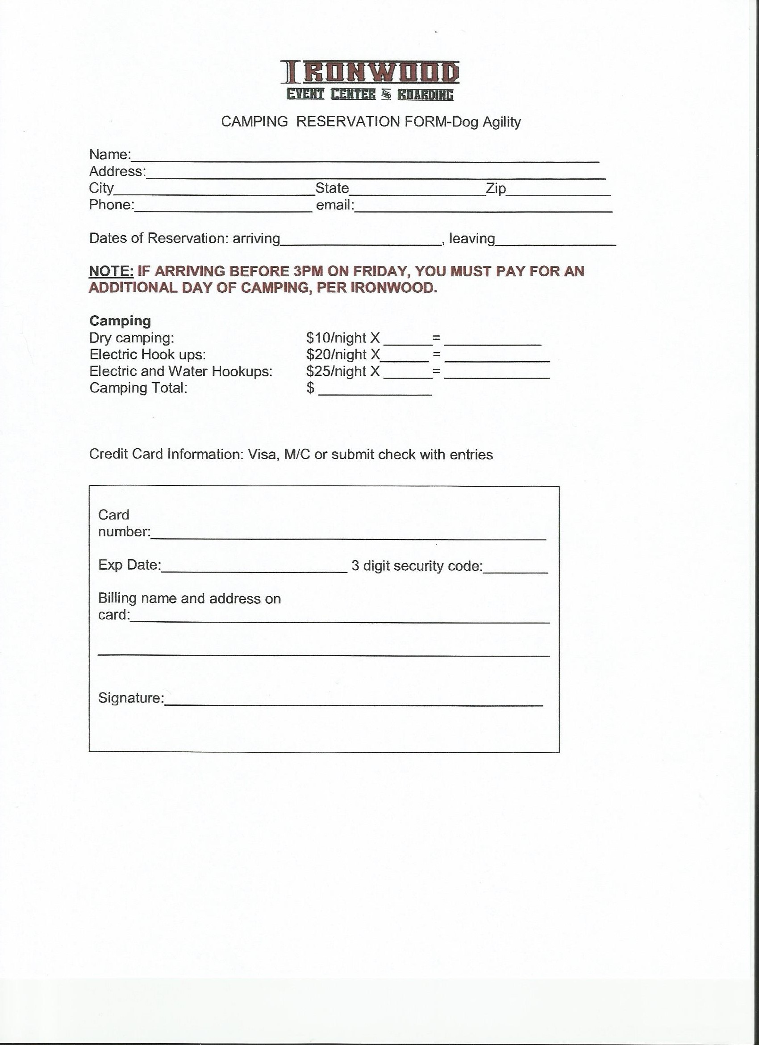

IRONWOOD EVENT CENTER
LUNCH ORDER FORM
APRIL 18 AND 19, 2020

LUNCH WILL INCLUDE SANDWICH, CHIPS, COOKIES AND A CHOICE OF DRINKS
$8.00

Saturday:
_____HAM/TURKEY/CHEESE COMBO
_____TUNA
_____EGG SALAD

SUNDAY
_____HAM/TURKEY/CHEESE COMBO
_____TUNA
_____EGG SALAD

Name___________________________________________

